Game Design Document

Fill up the following document

1. Write the title of your project.

Song guesser

1. What is the goal of the game?

Find thw name of the song

1. Write a brief story of your game.

This game is base on a very easy idea .A song will be running on the backgound the main task is to find song guess

1. Which are the playing characters of this game?

* Playing characters are the ones who respond to the user based on the input from the user.
* Cars, monkeys, dinos, wizards, etc., are the playing characters in the game.

|  |  |  |
| --- | --- | --- |
| Number | Character Name | What can this character do? |
| 1 | The player | to name the song |
| 2 |  |  |
| 3 |  |  |
| 4 |  |  |
| 5 |  |  |
| 6 |  |  |
| 7 |  |  |
| 8 |  |  |

1. Which are the Non-Playing Characters of this game?

* Non-Playing characters are the ones that don't have an action or behavior when the user interacts with the game.
* Hurdles, stones, bananas, coins, etc., are non-playing characters in the game.

|  |  |  |
| --- | --- | --- |
| Number | Character Name | What can this character do? |
| 1 | The DJ | To play the song to the pc is a mix form to player to player |
| 2 | The instructor | To instructor the player how to play the game |
| 3 | The workes | To hand over the prize to the player |
| 4 |  |  |
| 5 |  |  |
| 6 |  |  |
| 7 |  |  |
| 8 |  |  |

Draw your imagination of this game. What does this game look like?

* Draw the game either on your computer or on paper.
* Add images of the game scenes to show each of the playing and non-playing characters at least once.

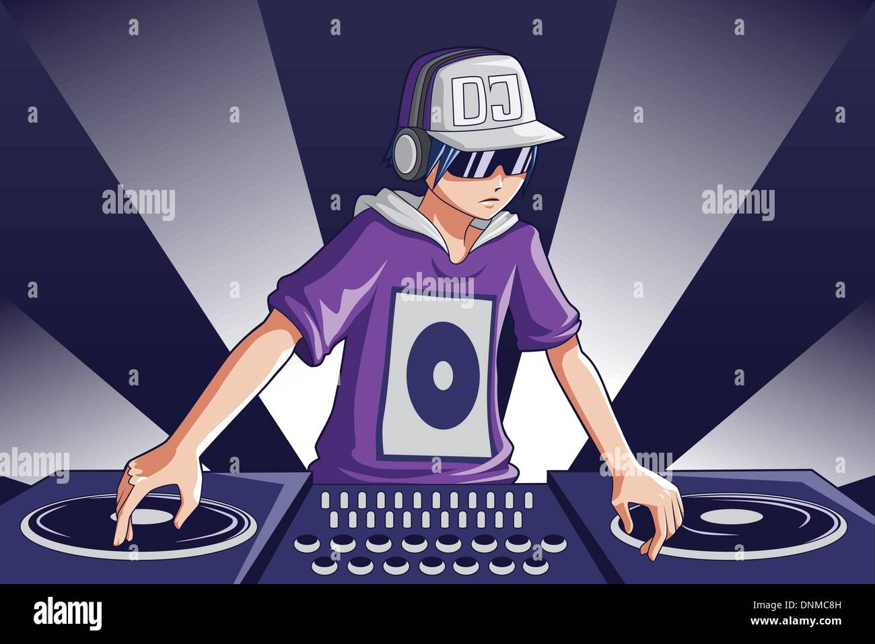

How do you plan to make your game engaging?

By changing the speed of the song ,by playing a remix ver of the song play all lang song